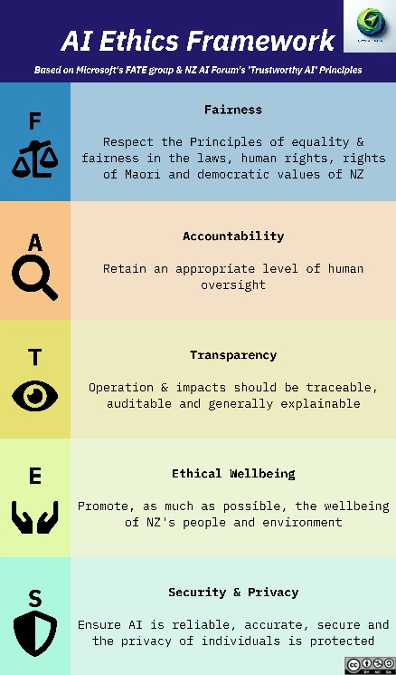
LinkedIn Posts – FATES Security&Privacy
✨ “𝐓𝐡𝐚𝐭’𝐬 𝐧𝐨𝐭 𝐟𝐚𝐢𝐫!” – 𝐀 𝐌𝐢𝐧𝐢-𝐒𝐞𝐫𝐢𝐞𝐬 𝐨𝐧 𝐄𝐭𝐡𝐢𝐜𝐬 𝐢𝐧 𝐀𝐈 ✨

#EthicalAI #AIForBusiness #AITraining #FATESFramework
_____________________________________________

